**Branch: - Computer Science and Engineering Class: - III Year**

**Subject: - C-Skill Lab-IV Sem: - VI**

**Teacher Manual**

**PRACTICAL NO. 6**

**Aim:** Setup Git repository locally.

## **Git Repository:**

The purpose of Git is to manage a project, or a set of files, as they change over time. Git stores this information in a data structure called a **repository**. In short, Git Repository is a collection of all project files along with their history. It is a virtual storage of project where all the resources/files of the project along with a special folder called **.git** is kept. The .**git**folder in a git repository is used by GIT programs to store information about the repository like Logs, Position of Head, and more. It allows you to save versions of your code, which can be accessed, tracked, and managed.

**Getting a Git Repository:**

A Git repository can be obtained in one of two ways:

1. take a local directory that is currently not under version control, and turn it into a Git repository, or
2. clone an existing Git repository from elsewhere.

Steps:

1. Install [Git](https://www.theserverside.com/blog/Coffee-Talk-Java-News-Stories-and-Opinions/Step-by-step-guide-to-install-Git-on-Windows-desktop-computers) on local machine.

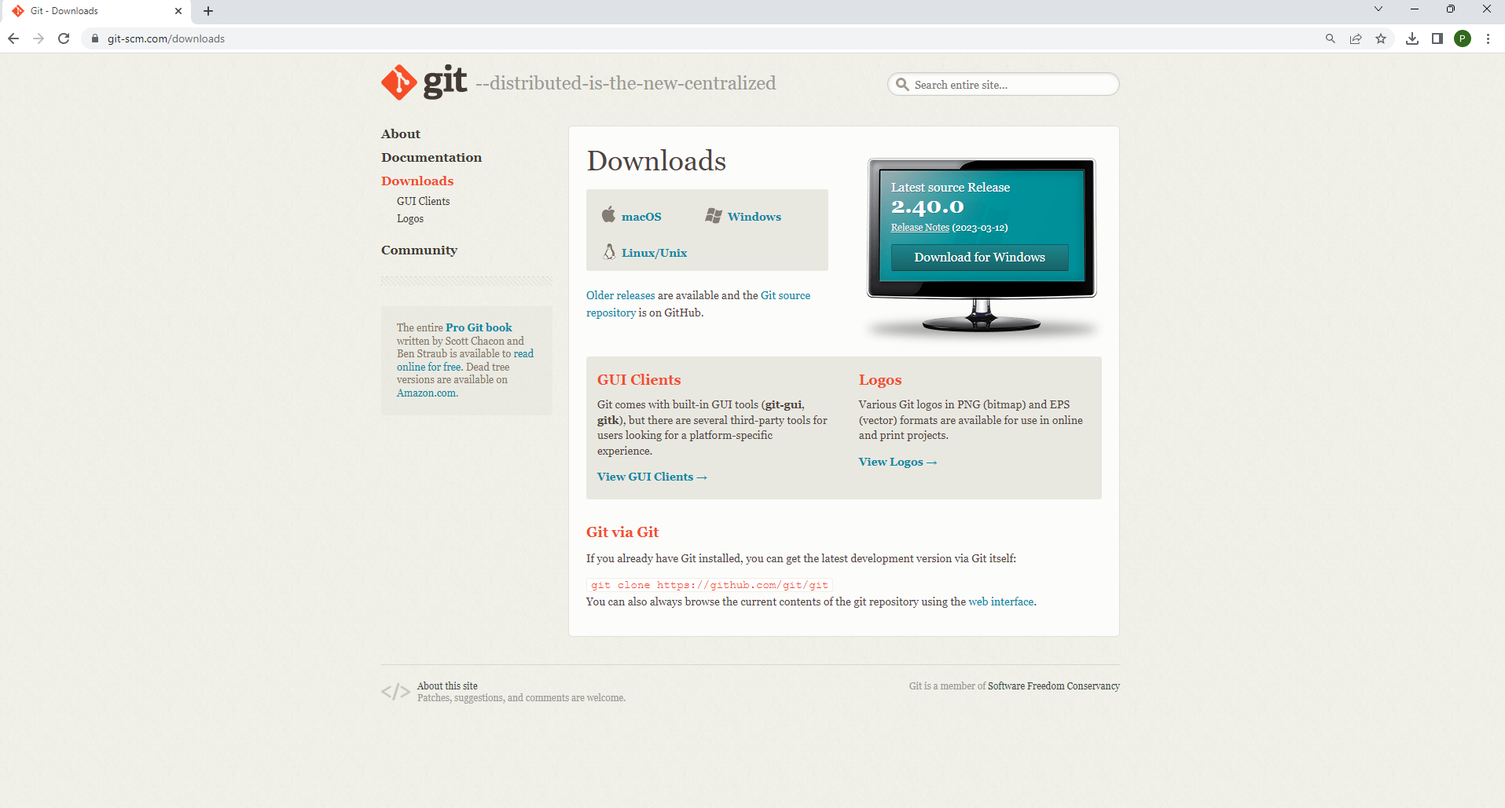

1. Create new folder named "local-repository" on desktop.

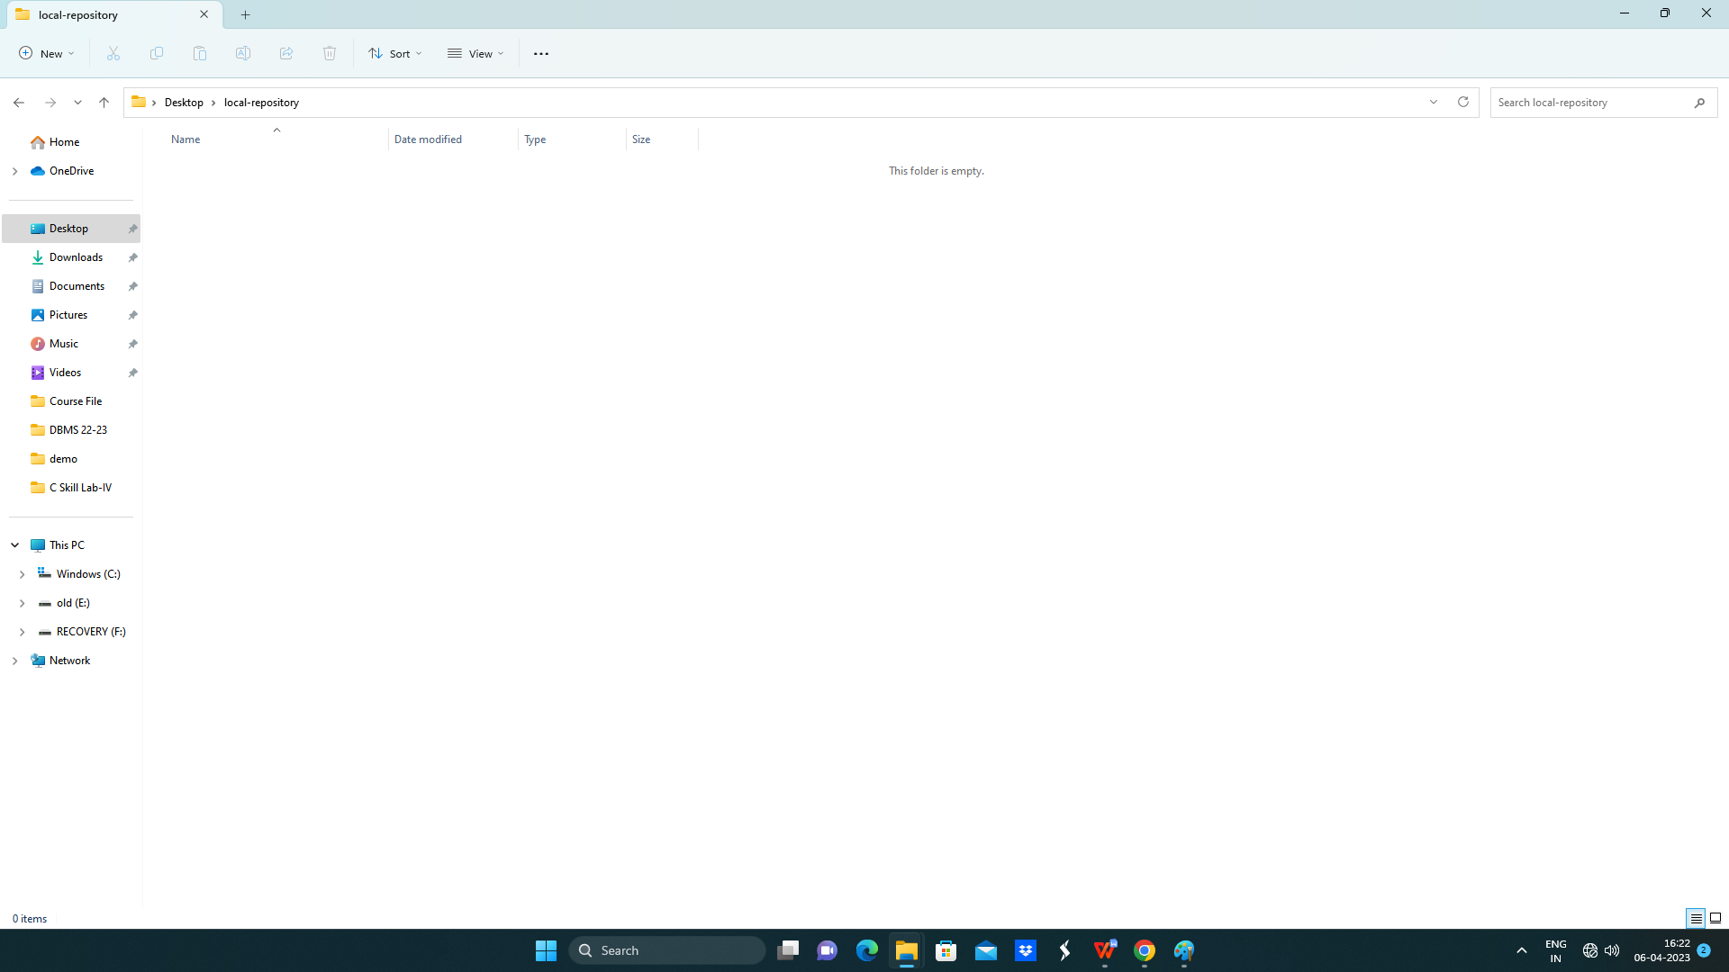

1. Right click inside the newly created folder and choose “GitBash Here”.

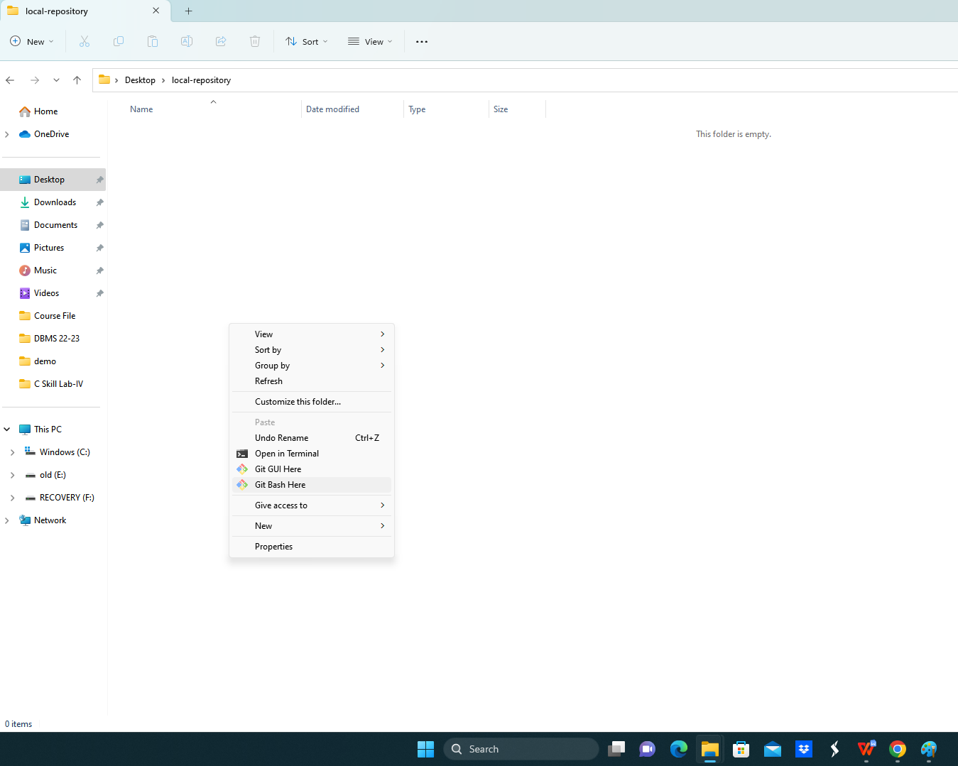

1. Within that folder, create three files that will be added into the new Git repository when it is created.

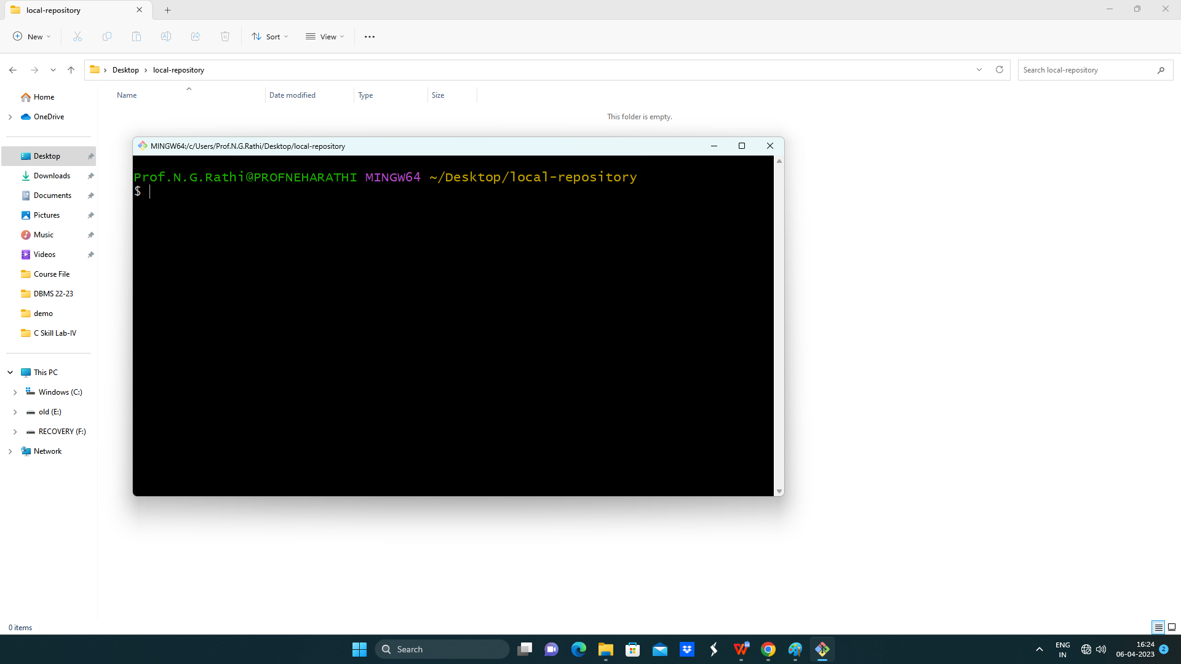

1. Accomplish this easily, by issuing the **touch** command three times with the Git BASH shell inside the newly created folder.

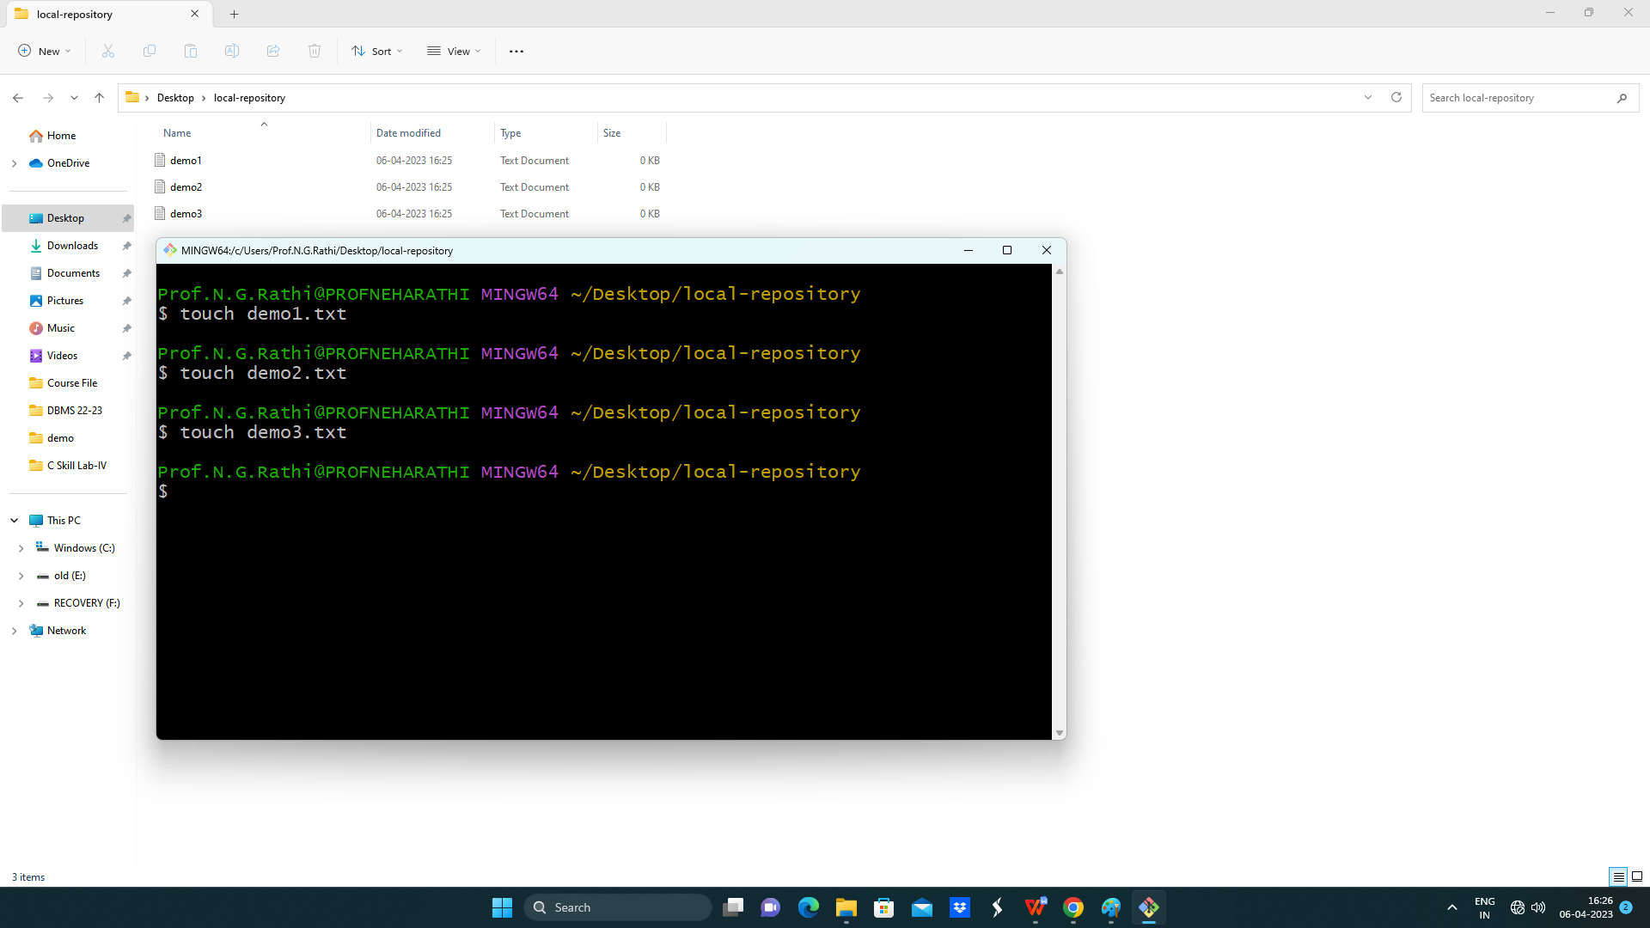

1. Add content to these files using cat command.

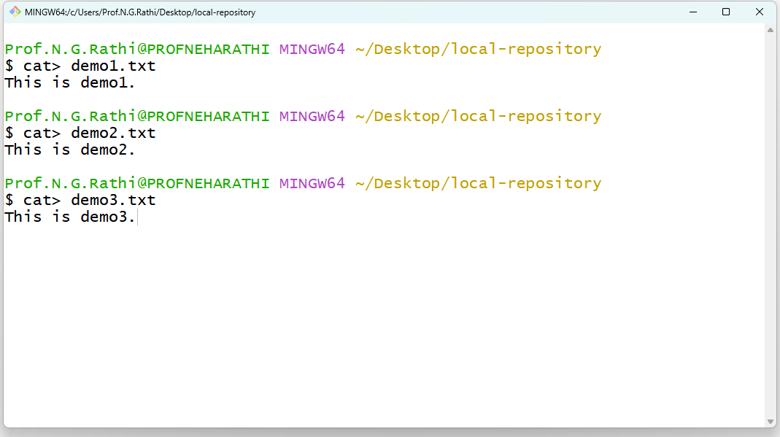

1. After creating these files, the next step is to create the source code repository through the invocation of the git init command.

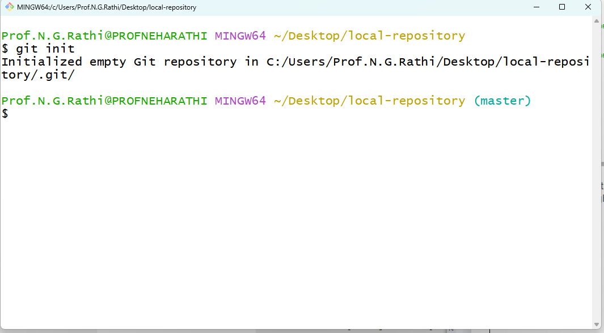

1. Note that after the git init command, inform the tool about user name and email address.

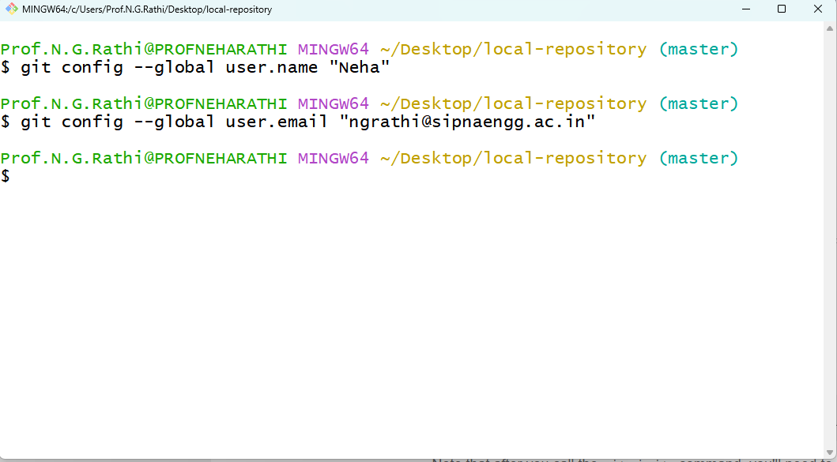

1. Add files to the Git index. With these steps completed, you can now add the three files created earlier to the Git tracking system -- also known as the Git index -- with the **git add .** command.

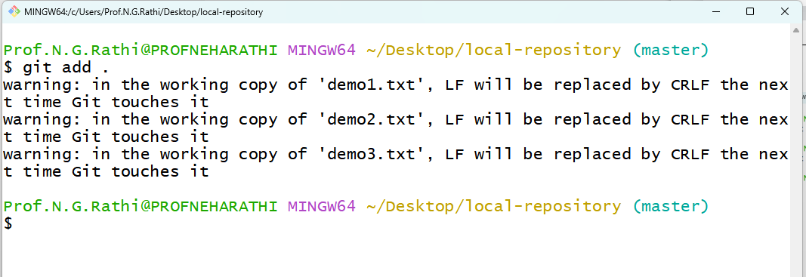

1. Perform a git commit and check status.

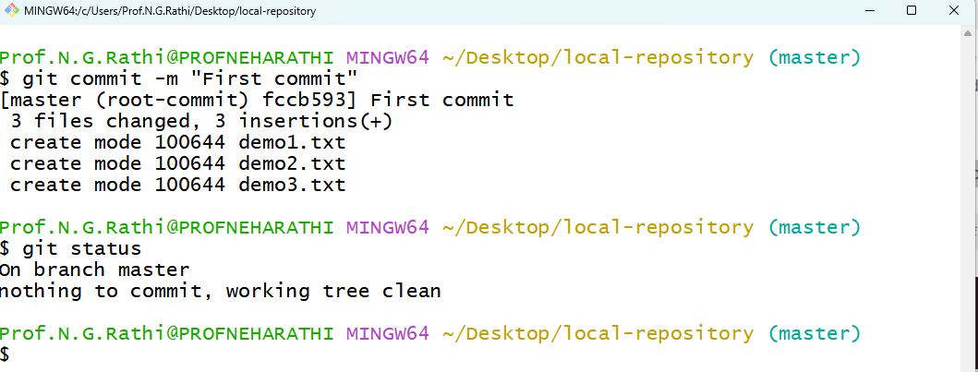

**Conclusion:** Thus I have created git repository locally.